Organ Systems in Humans
Every cell in the body needs a steady supply of food and oxygen to give it energy. Three different organ systems are needed and must work together to make this possible. They are the digestive system, the respiratory system, and the circulatory system.
Food first enters the digestive system through the mouth, then it passes to the stomach and the small intestine. It is broken down along the way into small, soluble particles that can be used by your cells. Unused food is expelled from your body as waste. The organs that form your digestive system are your tongue, salivary glands, esophagus, liver, stomach, pancreas, gallbladder, large intestine, small intestine, rectum, and anus.
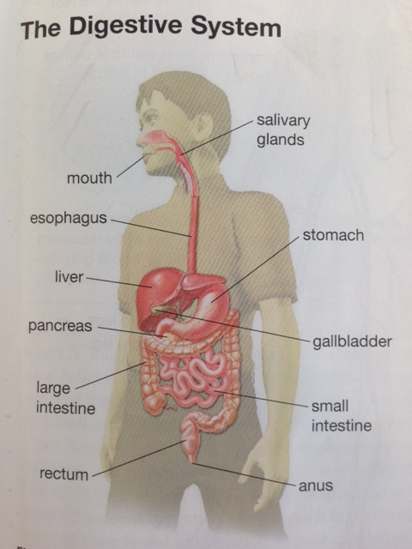
Breathing in is called inhalation. When we inhale, our lungs fill with oxygen-containing air. Breathing out is called exhalation. When we exhale we rid our bodies of waste carbon dioxide. The organs involved in this gas exchange are called the respiratory system. The organs that form the respiratory system are the larynx, the trachea, the alveolus, the bronchus, the bronchioles, the lungs, and the diaphragm.
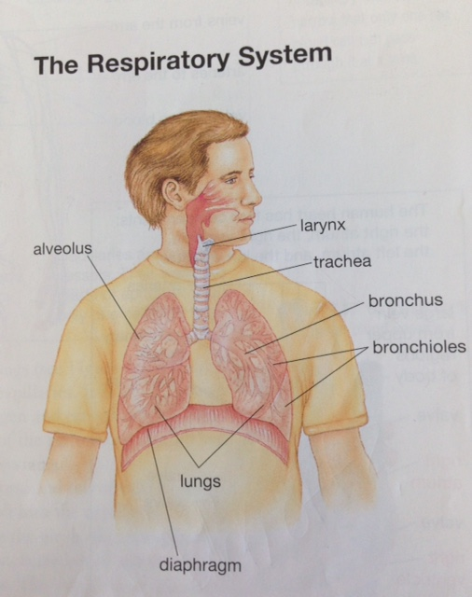
The digestive system puts food into the intestine and the respiratory system puts oxygen in the lungs. How do particles of food and oxygen eventually get from these systems to cells in the toes, the brain, and other parts of the body? A third system transports particles of food and oxygen. This system in called the circulatory system. This system includes the heart, blood, and blood vessels such as arteries, veins, and capillaries. The circulatory system circulates blood around the body, delivering food particles, dissolved gases, and other materials to every cell and carrying away cell wastes.
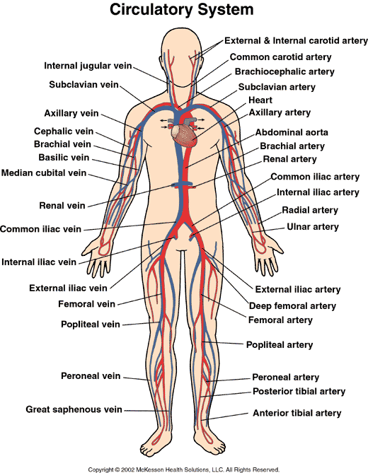
There are about 11 different systems in the human body. Each system has a major function. The systems are coordinated into the total living organism, and all the systems depend on one another.

